NodeJS Hands on Exercise:

1. Install Node from the following Link:

<https://nodejs.org/en/>

Verify the installation using node -v

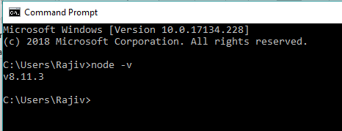

1. Create a folder with name **273_InClass_Activity**. Open Command Prompt/ Terminal inside that directory and run **npm-init.** Press enter to keep defaults.

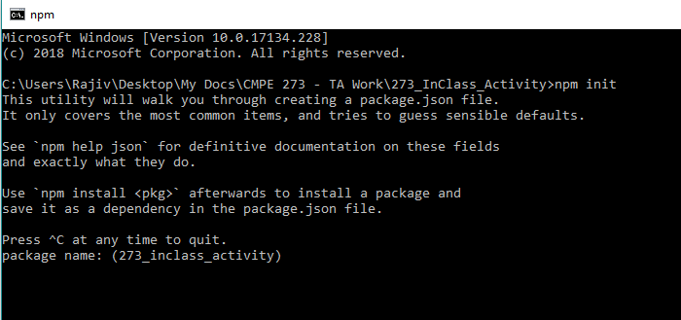

This will create a package.josn file inside your project.

1. Install Express and other dependencies using npm.
   1. npm install express –save

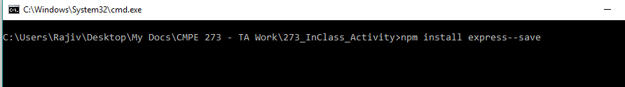

* 1. This will create a folder called **node_modules** inside your project directory.

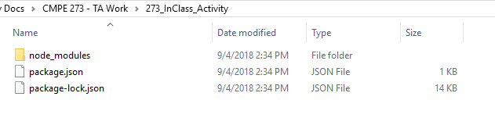

* 1. Also check package.json to see the dependencies section.

1. Open your project folder inside Visual Studio Code.

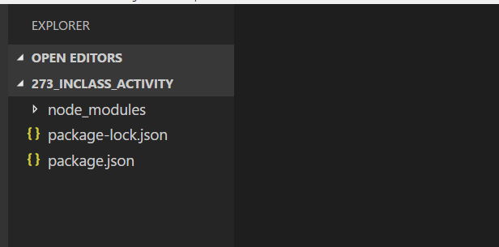

1. Create a file called “index.js” in the root of your project directory. (Do not create inside node_modules folder)
2. Create a simple Hello World Program using express:
   1. Step 1: Require Express into your app file.
   2. Step 2: Create an express app.
   3. Step 3: Create a GET route for ‘/’ and return “Hello World” using response.

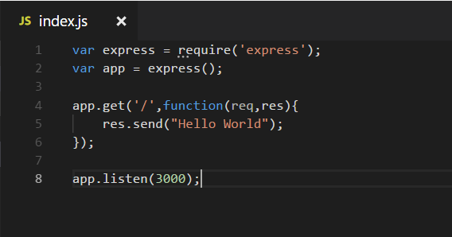

1. Run the application using node index.js

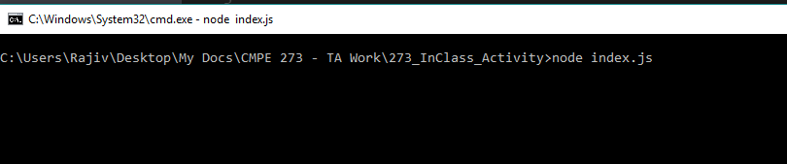

1. Open Browser and go to localhost:3000 to run the program. You will see the following output.

